We have a dataset of sales of different TV sets across different locations. Records look like: Samsung|Optima|14|Madhya Pradesh|132401|14200

The fields are arranged like:

Company Name|Product Name|Size in inches|State|Pin Code|Price sales_differentTV : https://github.com/prateekATacadgild/DatasetsForCognizant/blob/master/sales_differentTV.txt

There are some invalid records which contain 'NA' in either Company Name or Product Name.

Dataset**:**

Samsung|Optima|14|Madhya Pradesh|132401|14200

Onida|Lucid|18|Uttar Pradesh|232401|16200

Akai|Decent|16|Kerala|922401|12200

Lava|Attention|20|Assam|454601|24200

Zen|Super|14|Maharashtra|619082|9200

Samsung|Optima|14|Madhya Pradesh|132401|14200

Onida|Lucid|18|Uttar Pradesh|232401|16200

Onida|Decent|14|Uttar Pradesh|232401|16200

Onida|NA|16|Kerala|922401|12200

Lava|Attention|20|Assam|454601|24200

Zen|Super|14|Maharashtra|619082|9200

Samsung|Optima|14|Madhya Pradesh|132401|14200

NA|Lucid|18|Uttar Pradesh|232401|16200

Samsung|Decent|16|Kerala|922401|12200

Lava|Attention|20|Assam|454601|24200

Samsung|Super|14|Maharashtra|619082|9200

Samsung|Super|14|Maharashtra|619082|9200

Samsung|Super|14|Maharashtra|619082|9200

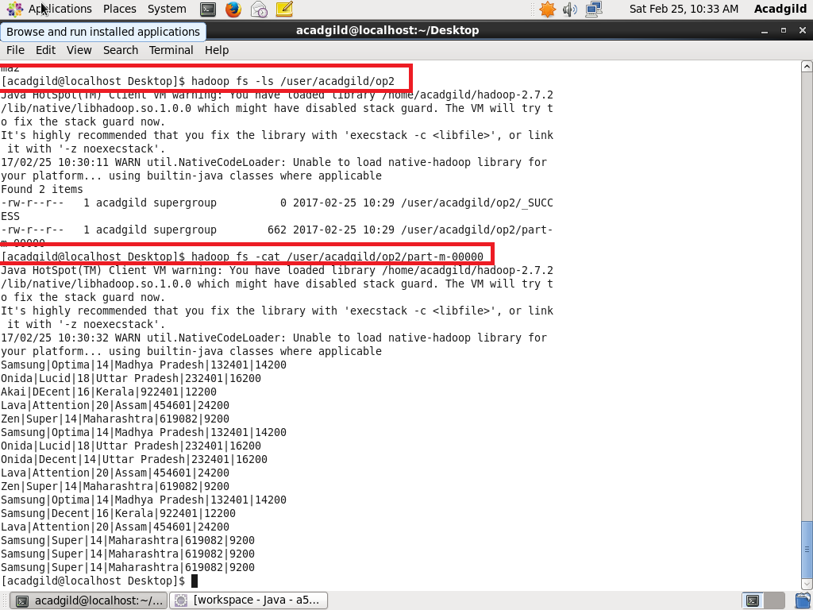

**Sales of different TV Task 2:**

PROGRAM**:**

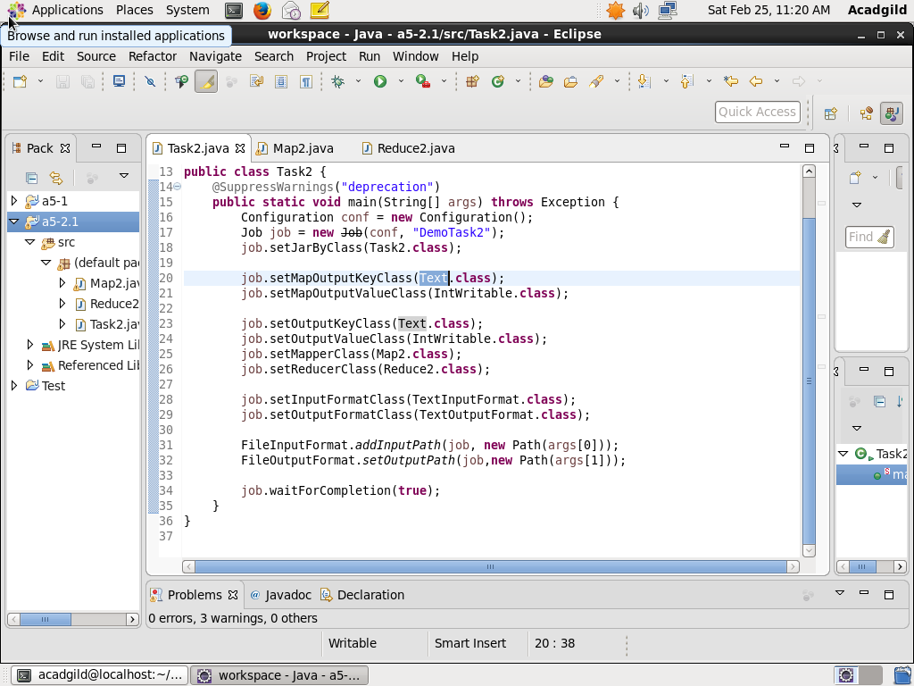

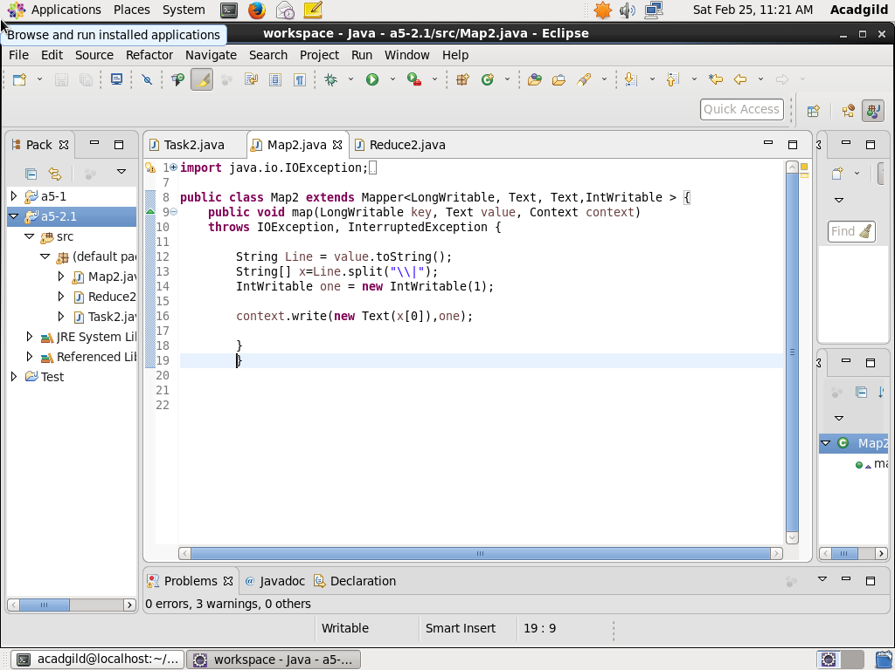

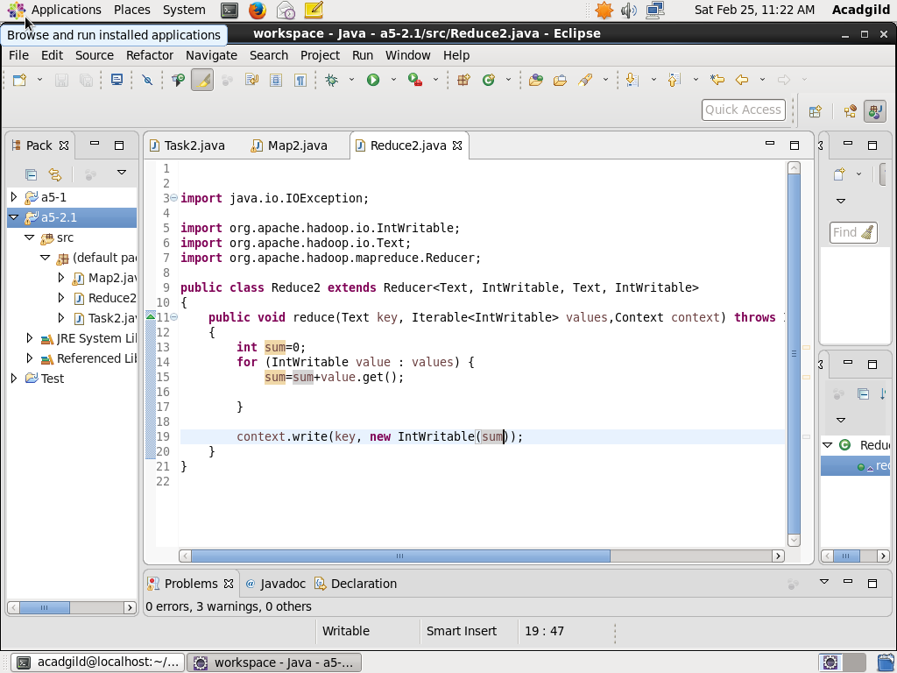

OUTPUT**:**

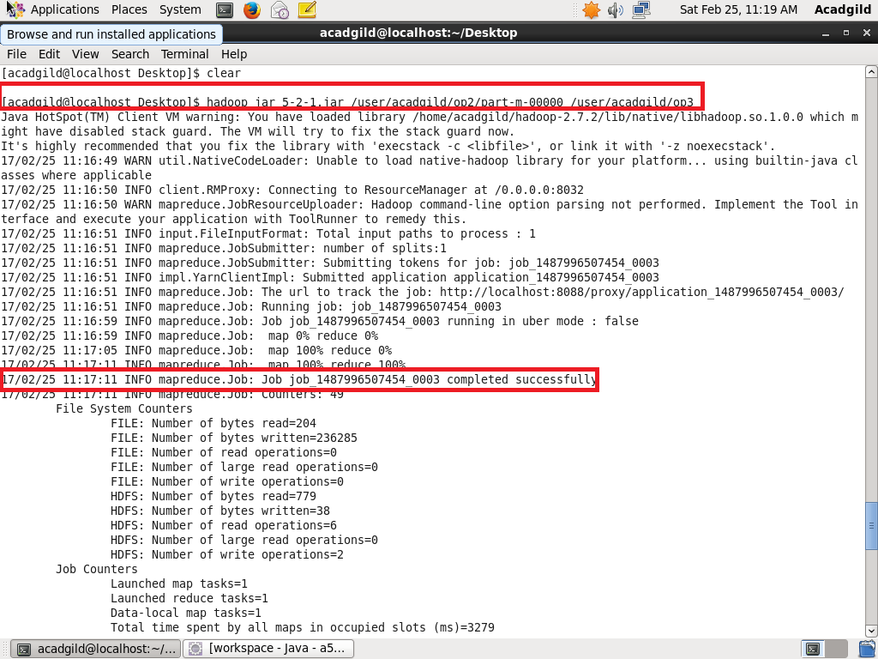

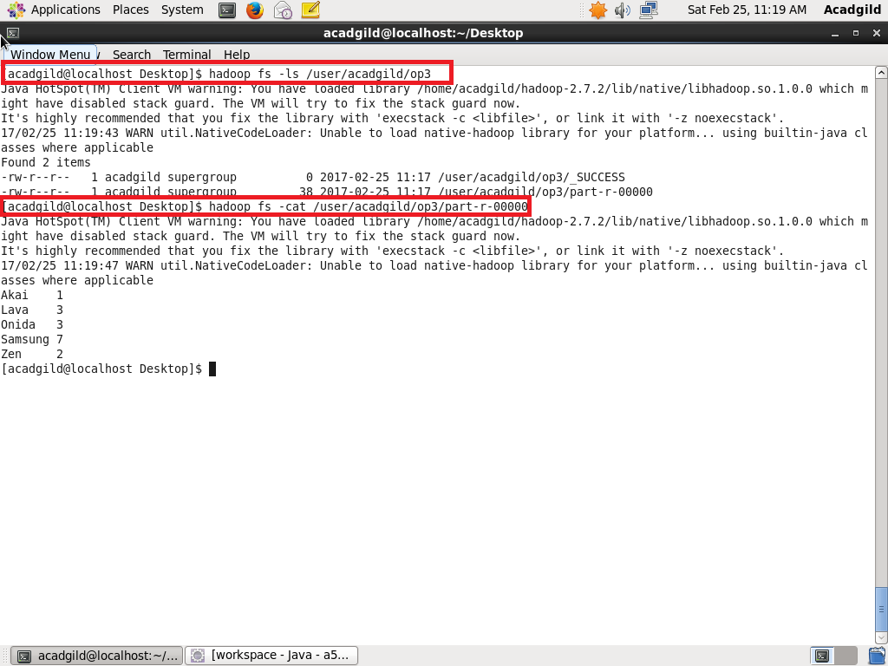

**Sales of different TV Task 3:**

PROGRAM**:**

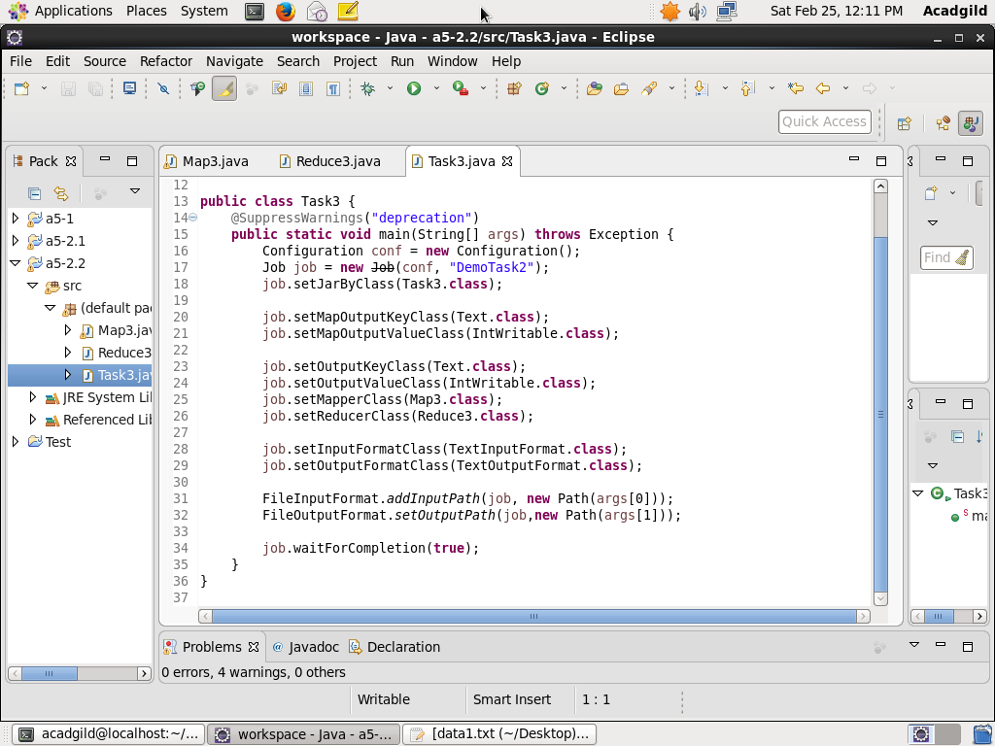

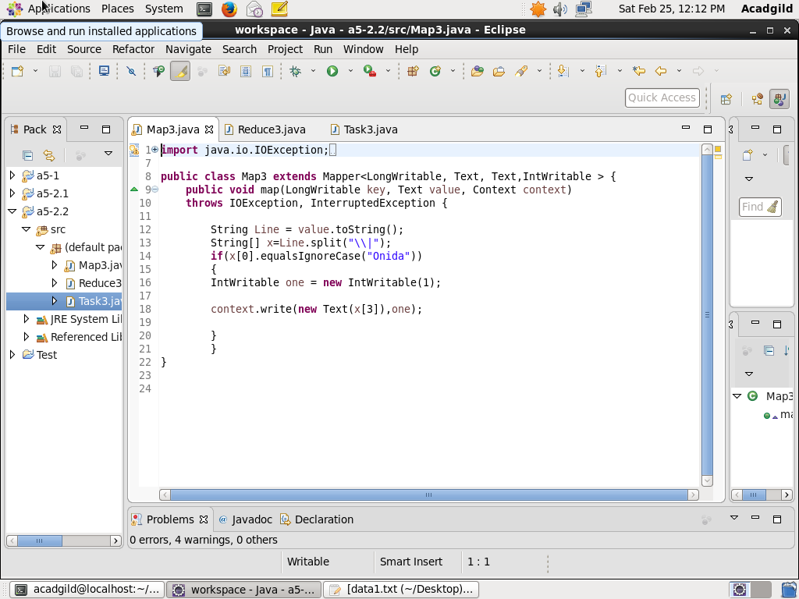

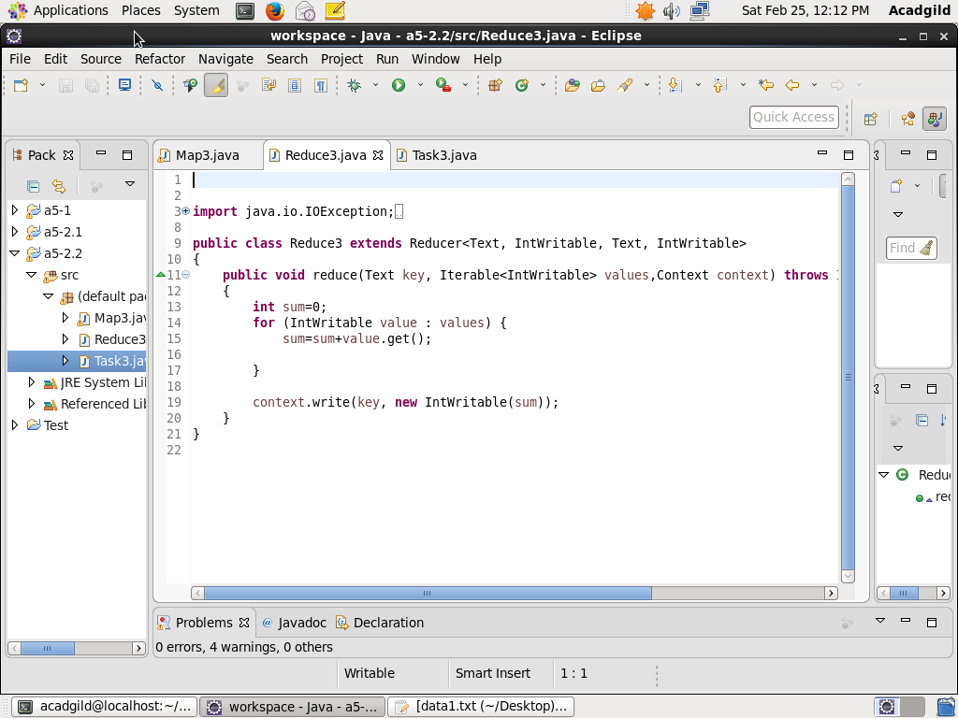

OUTPUT**:**

